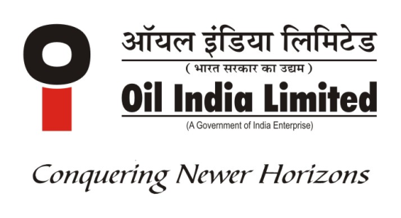 | OIL INDIA LIMITED  P.O. DULIAJAN – 786 602  DIST. DIBRUGARH  ASSAM, INDIA

Seminar cum Workshop at Ahmedabad , November-2023

As you are aware, Oil India Limited (OIL) , a Maharatna company , procures Goods & Services from Vendors across the globe aligning with Government Policies and procedures in vogue to support its Operational requirements of diversified nature. OIL’s annual procurement including all goods and services is around Rs. 5000 Crore. After the restriction of import below Rs. 200.00 Cr. by the government organizations, Oil India Limited is emphasizing on import substitution under Atma Nirbhar Bharat campaign of Govt. of India through development of Indigenous sources to meet Oil field requirements.
Oil India limited is organising a Seminar cum Workshop at Ahmedabad on 09.11.2023 where all our interested vendors are invited . The primary objective of this Seminar cum Workshop is :
To interact with vendors for identifying domestic capacity, capability and expected timeline for indigenisation of the goods/services .

Oil India Limited will be delighted to receive your participation request for the Seminar cum Workshop as per attached Registration Form. Please mail the filled in form to email ID: Seminar_Nov23@oilindia.in on or before 05.11.2023.

Maximum two participants will be allowed to attend from one company.

(Exact venue will be intimated in due course. Time: 2:00 PM )

Click here to download the Registration form !!
xxxxxxxxxx

